**1)Install git**

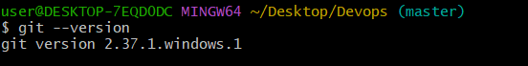

**2)Create a repo in github with README.md and .ignore file**

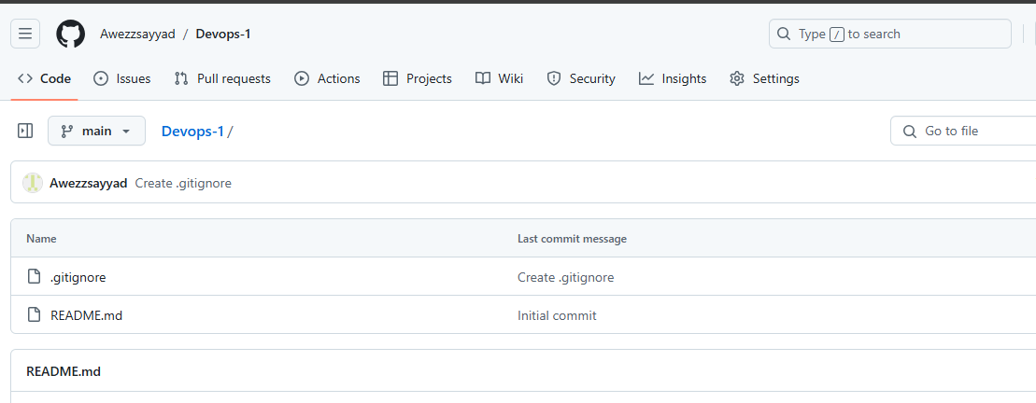

**3)Clone the created repo to local**

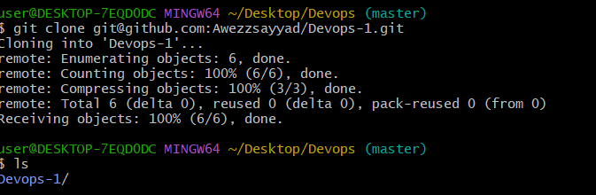

**4)Create two files in local repo. & 5)Commit two files and push to central Repository.**

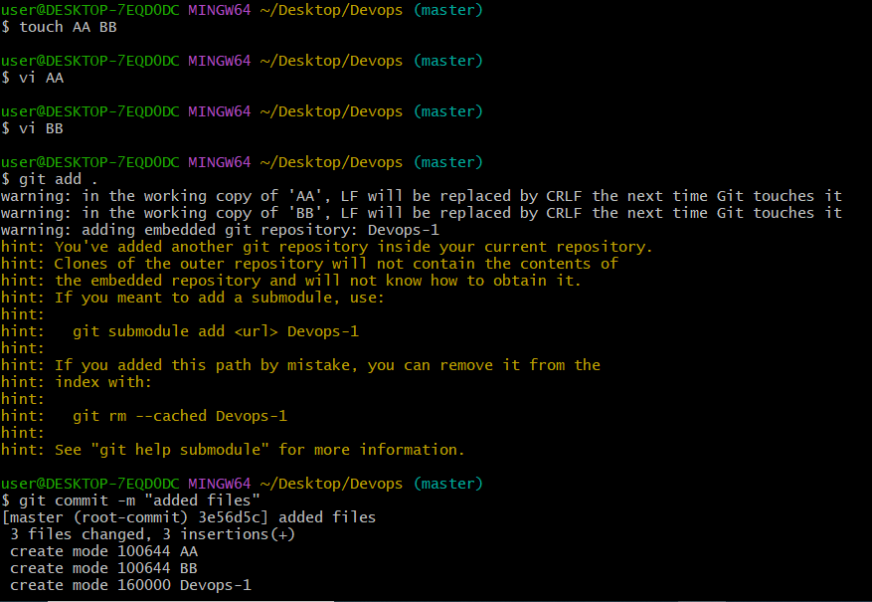

**6) Create a branch in local and create a sample file and push to central.**

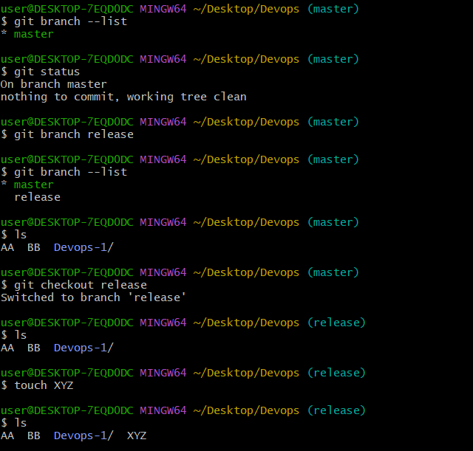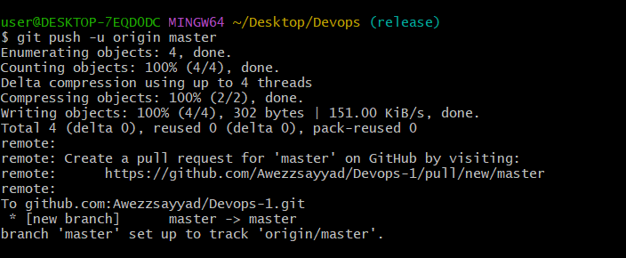

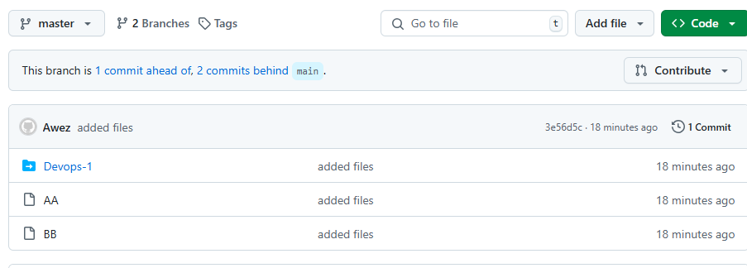

**7)Create a branch in github and clone that to local.**

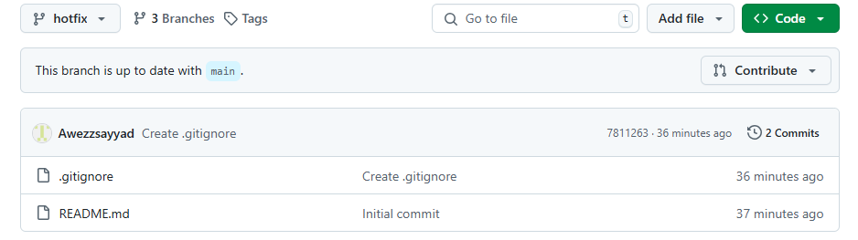

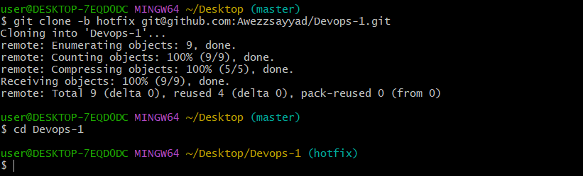

**8)Merge the created branch with master in git local.**

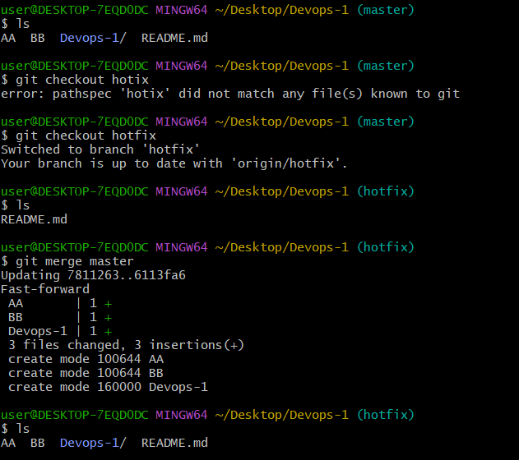

**9)Merge the created branch with master in github by sending a pull request.**

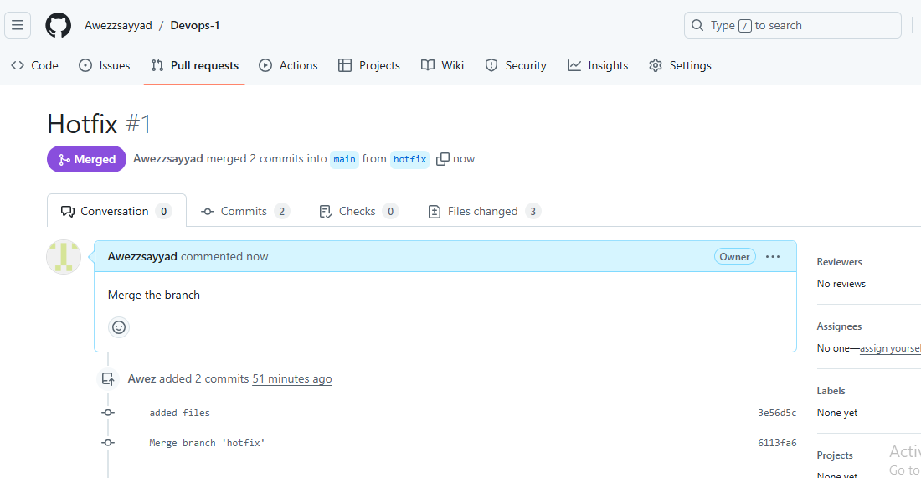

**10)create a file in local and send that to branch in github.**

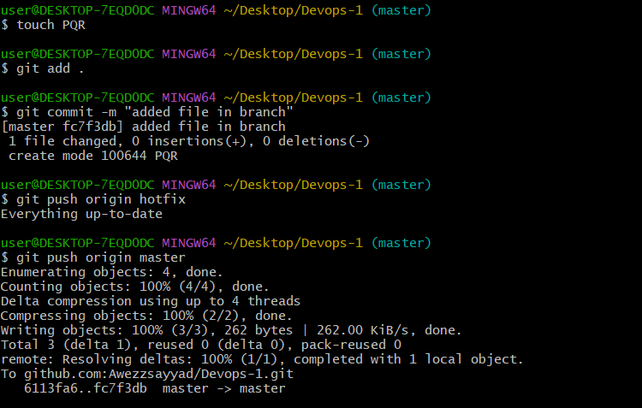

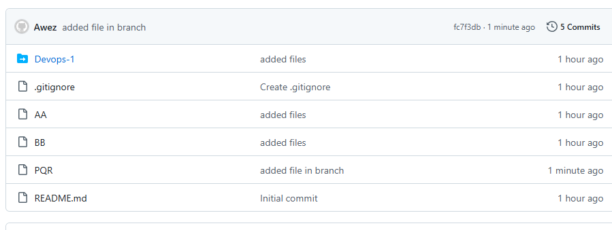

**11)clone only a branch from github to local.**

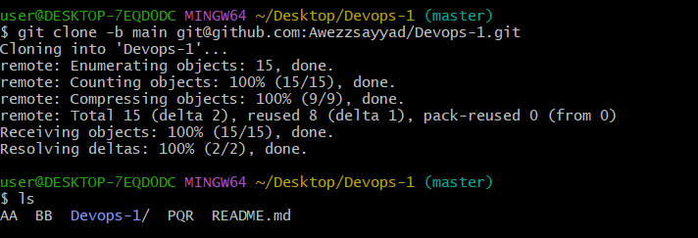

**12)create a file with all passwords and make that untrackable with git.**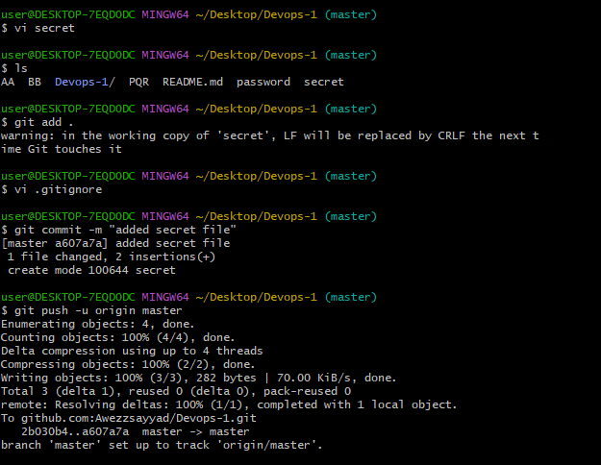

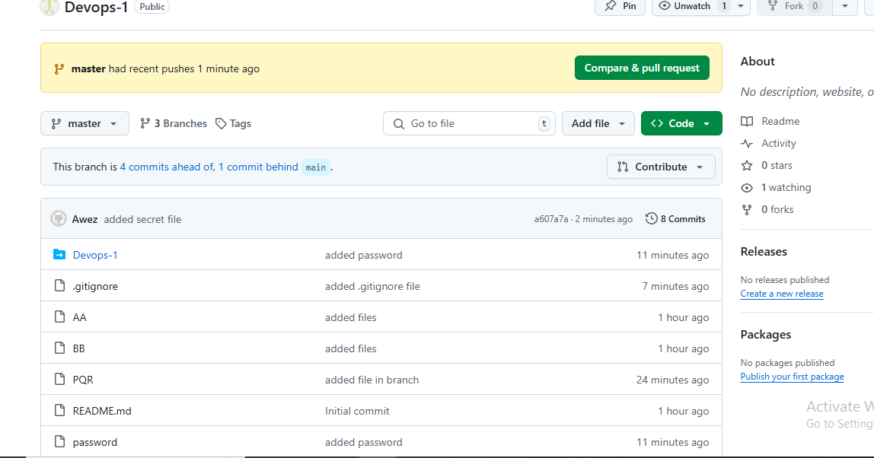

**13)make a commit and make that commit reset without savings changes.**

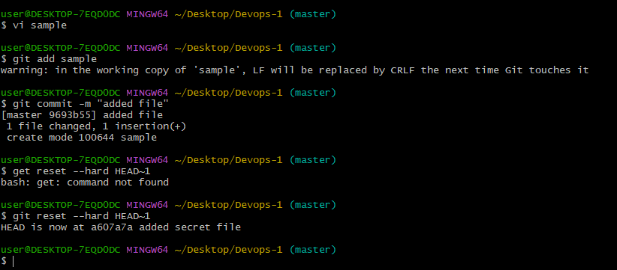

**14)Revert a commited commit to the older version.**

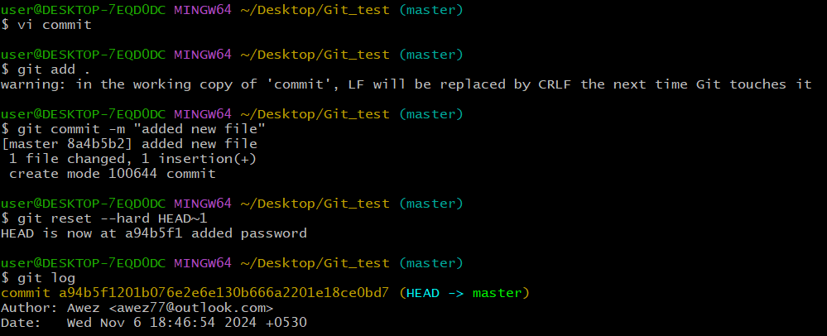

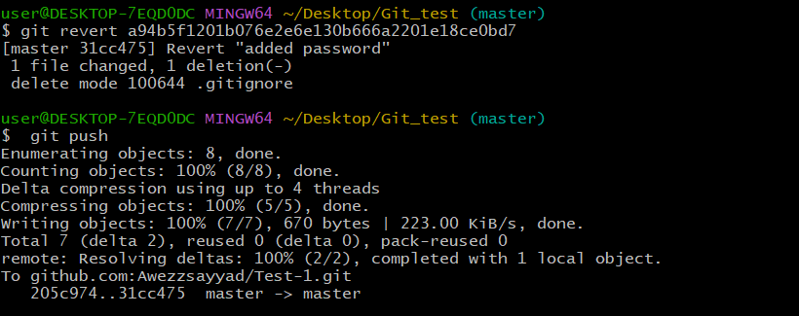

**15) push a file to stash without savings the changes and work on another file**.

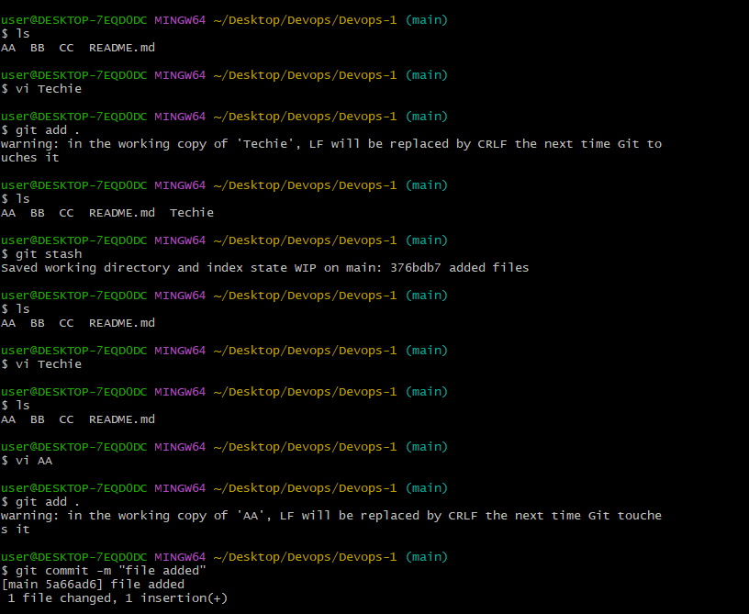

**16)undo the stash file and start working on that again.**

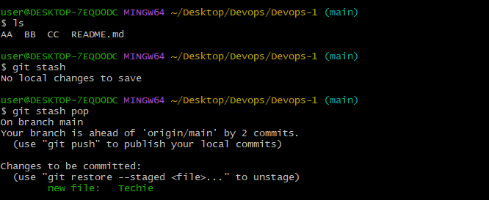

**17)generate a ssh-keygen and configure into github.**

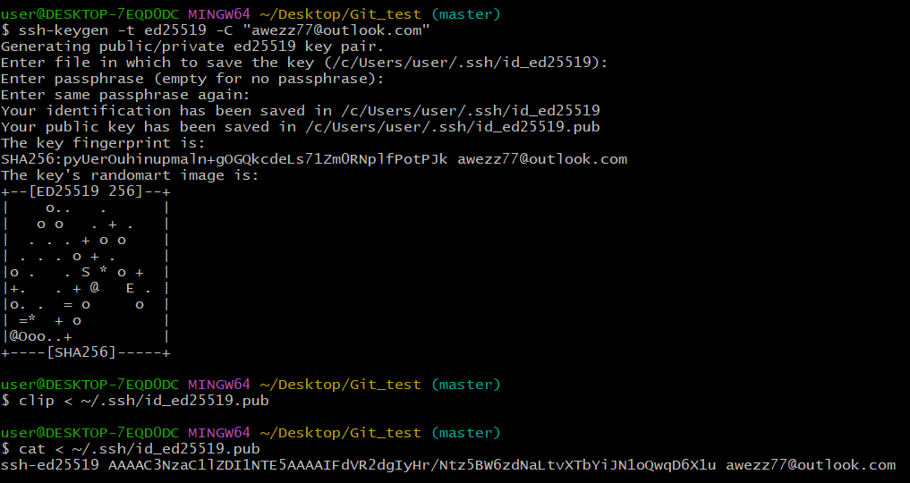

18)configure webhooks to github.

**19)basic understanding of .git file.**

**The .git file is crucial for managing a Git repository. It is actually a directory named .git located at the root of your project. This directory contains all the metadata and object database of your Git repository. A . git folder is required to log every commit history and every other information required for your remote repository, version control, commits etc.**

**20)Check all the logs of git.**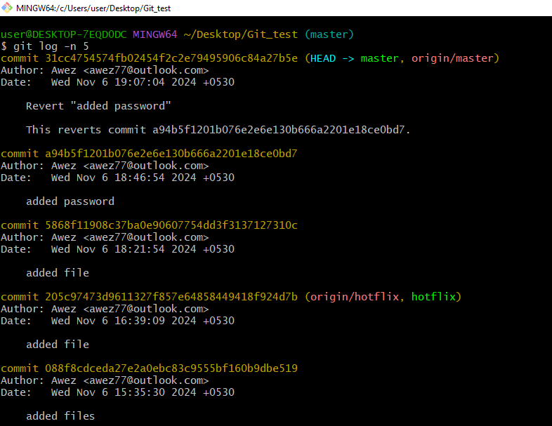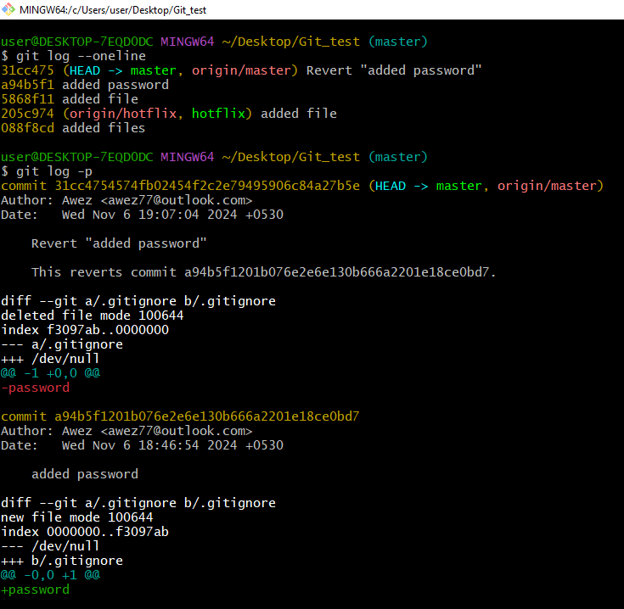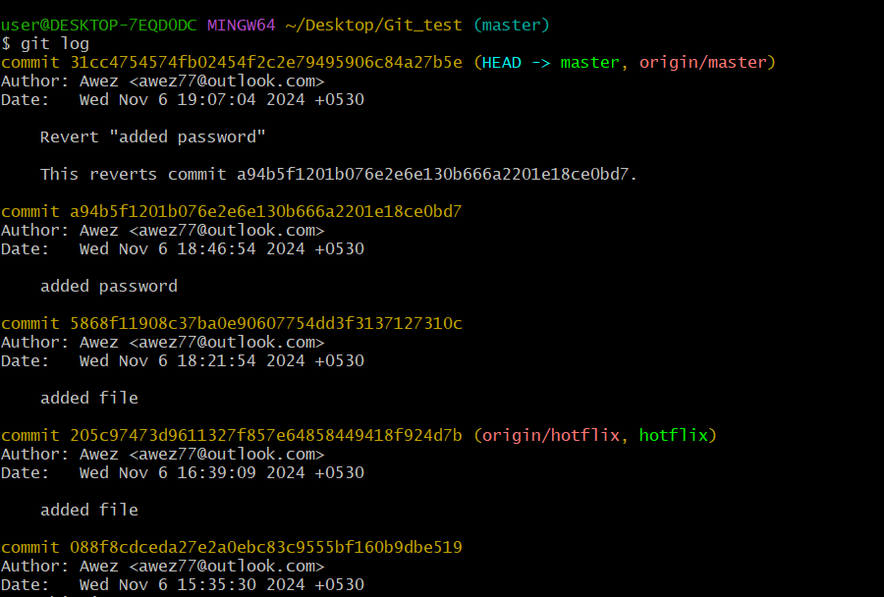

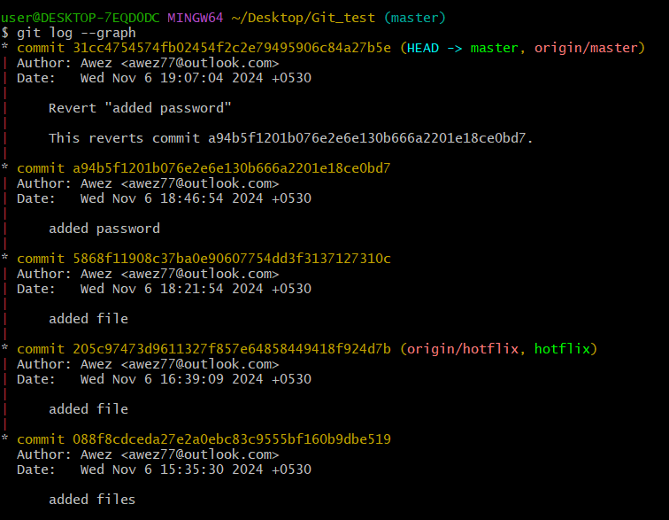

**21)Rename the commit message.**

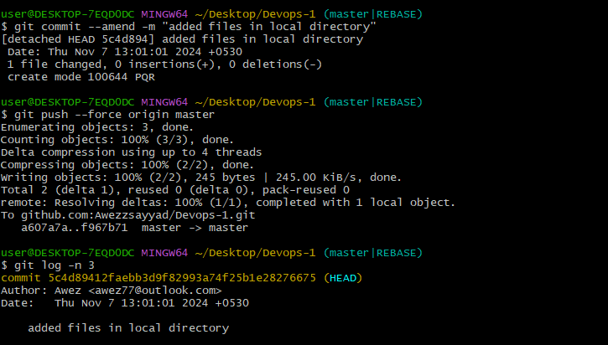

**22)Merge multiple commits into single commit.**

